Name: G.Madhubala
Reg. No: 192372035
DSA1604 – Knowledge Engineering and Data Science

Experiment 1: Knowledge Representation Using Python

Aim
To represent facts about a student using a Python dictionary and display the stored knowledge.

Software Required
Python 3.x (IDLE / any Python IDE)

Algorithm
- Start the program. Decide which facts about the student need to be stored: name, department, course and year.
- Create a dictionary named student. Each fact is stored as a key–value pair, for example "name": "Arun", so every attribute can be looked up by its key.
- Print the heading. Display "Student Knowledge Representation" so the output is clearly labelled.
- Traverse the dictionary. Use the items() method inside a for loop, which returns each key together with its value one pair at a time.
- Display each fact. In every iteration print the key, a colon and the value, so each attribute appears on its own line.
- Stop the program. The loop ends automatically after the last key–value pair has been displayed.

Pseudocode
START
CREATE dictionary student name <- "Arun" department <- "CSE"
course <- "Python Programming" year <- 2
DISPLAY "Student Knowledge Representation" FOR EACH (key, value) IN student
DISPLAY key, ":", value END FOR
STOP

Program
student = { "name": "Arun",
"department": "CSE",
"course": "Python Programming", "year": 2
}

print("Student Knowledge Representation") for key, value in student.items():
print(key, ":", value)

Output Screenshot
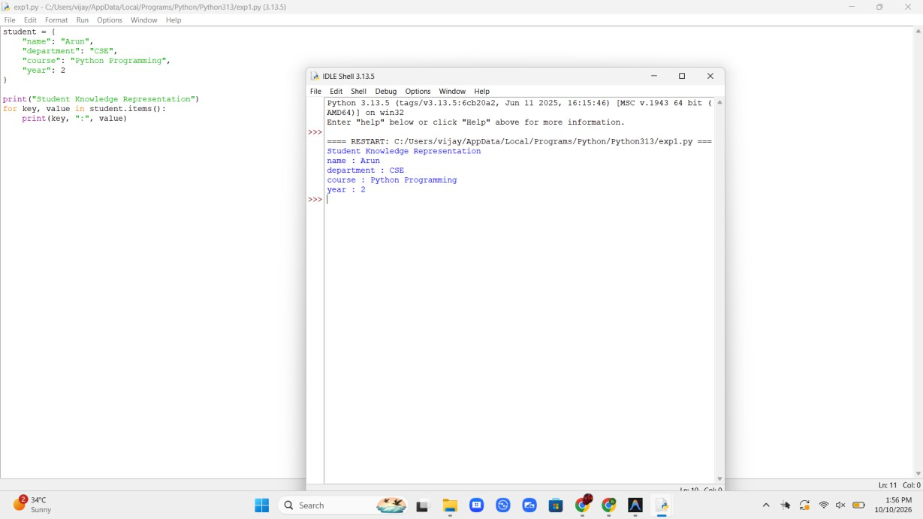
Fig 1. Output of Experiment 1

Result
Knowledge was represented as structured facts using a Python dictionary and displayed successfully.

Experiment 2: Knowledge Acquisition

Aim
To acquire knowledge from a user and store it as structured facts.

Software Required
Python 3.x (IDLE / any Python IDE)

Algorithm
- Start the program. Plan to collect three facts about an expert: name, area of expertise and years of experience.
- Read the expert's name. Use input() to accept the name from the user as a string and store it in the variable name.
- Read the area of expertise. Use input() again and store the domain as a string in the variable domain.
- Read the years of experience. Accept the value with input() and convert it to an integer using int(), so it can be used in calculations later.
- Store the facts in a dictionary. Create a dictionary named knowledge with the keys "expert", "domain" and "experience" holding the three values.
- Display the acquired knowledge. Print each fact by reading it back from the dictionary using its key.
- Stop the program.

Pseudocode
START
READ name READ domain READ experience
CONVERT experience TO integer CREATE dictionary knowledge
expert <- name domain <- domain
experience <- experience DISPLAY "Acquired Knowledge"
DISPLAY "Expert:", knowledge["expert"] DISPLAY "Domain:", knowledge["domain"]
DISPLAY "Experience:", knowledge["experience"], "years" STOP

Program
name = input("Enter expert name: ") domain = input("Enter area of expertise: ")
experience = int(input("Enter years of experience: "))

knowledge = { "expert": name, "domain": domain,
"experience": experience
}

print("\nAcquired Knowledge") print("Expert:", knowledge["expert"]) print("Domain:", knowledge["domain"])
print("Experience:", knowledge["experience"], "years")

Output Screenshot
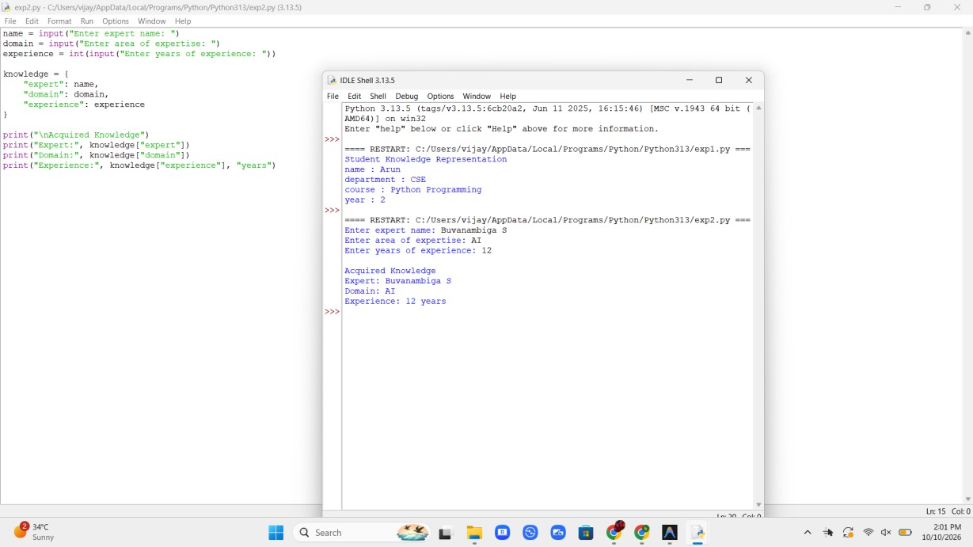
Fig 2. Output of Experiment 2

Result
Knowledge was collected from the user and stored in a structured form.

Experiment 3: Knowledge-Based Course Recommendation System

Aim
To recommend a course using a small knowledge base and decision rules.

Software Required
Python 3.x (IDLE / any Python IDE)

Algorithm
- Start the program. The knowledge base consists of simple rules that link an area of interest to a course.
- Read the student's interest. Accept the interest (AI, Data or Web) using input(), then apply strip() and lower() to remove extra spaces and make the comparison case-insensitive.
- Apply rule 1. If the interest is "ai", set the course to "Artificial Intelligence".
- Apply rule 2. Otherwise, if the interest is "data", set the course to "Data Science".
- Apply rule 3. Otherwise, if the interest is "web", set the course to "Web Development".
- Apply the fallback rule. If none of the rules match, set the course to "No matching course found".
- Display the recommendation. Print the selected course and stop the program.

Pseudocode
START
READ interest
interest <- LOWERCASE(TRIM(interest))
IF interest = "ai" THEN
course <- "Artificial Intelligence"
ELSE IF interest = "data" THEN course <- "Data Science"
ELSE IF interest = "web" THEN course <- "Web Development"
ELSE
course <- "No matching course found" END IF
DISPLAY "Recommended Course:", course STOP

Program
interest = input("Enter your interest (AI, Data, Web): ").strip().lower()

if interest == "ai":
course = "Artificial Intelligence" elif interest == "data":
course = "Data Science" elif interest == "web":
course = "Web Development" else:
course = "No matching course found" print("Recommended Course:", course)

Output Screenshot
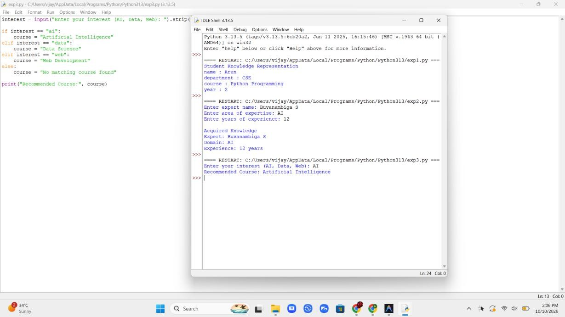
Fig 3. Output of Experiment 3

Result
The system used stored knowledge and rules to produce a course recommendation.

Experiment 4: Rule-Based Expert System for Network Troubleshooting

Aim
To build a rule-based expert system that infers a network troubleshooting action from the symptoms given by the user.

Software Required
Python 3.x (IDLE / any Python IDE)

Algorithm
- Start the program. The knowledge base consists of IF-THEN rules that link network symptoms to a fault and its remedy.
- Read the symptoms. Use input() to ask four yes/no questions: router power light, Wi-Fi connection, ping result and website access. Apply strip() and lower() to each answer.
- Apply rule 1. If the router light is off, conclude that the router has no power.
- Apply rule 2. Otherwise, if Wi-Fi is not connected, conclude that the device connection must be fixed.
- Apply rule 3. Otherwise, if the ping fails, conclude that there is no internet from the service provider.
- Apply rule 4. Otherwise, if websites do not open, conclude that there is a DNS problem.
- Apply the default rule. If no fault rule fires, conclude that the network is working normally.
- Display the diagnosis and stop. Print the advice selected by the rule that fired.

Pseudocode

START
READ router_light, wifi, ping, website IF router_light = "no" THEN
advice <- "Check power cable and adapter"
ELSE IF wifi = "no" THEN
advice <- "Turn Wi-Fi on and re-enter password"
ELSE IF ping = "no" THEN
advice <- "Restart router or call the provider"
ELSE IF website = "no" THEN
advice <- "Change the DNS server" ELSE
advice <- "Network is working normally" END IF
DISPLAY "Diagnosis:", advice STOP

Program
print("Network Troubleshooting Expert System")
router_light = input("Is the router power light ON? (yes/no): ").strip().lower() wifi = input("Is the device connected to Wi-Fi? (yes/no): ").strip().lower() ping = input("Does ping to 8.8.8.8 succeed? (yes/no): ").strip().lower() website = input("Do websites open in the browser? (yes/no): ").strip().lower()

if router_light == "no":
advice = "Router has no power. Check the power cable and adapter." elif wifi == "no":
advice = "Device is not connected. Turn Wi-Fi on and re-enter the password." elif ping == "no":
advice = "No internet from ISP. Restart the router or call the provider." elif website == "no":
advice = "DNS problem. Change the DNS server to 8.8.8.8." else:
advice = "Network is working normally." print("Diagnosis:", advice)

Output Screenshot
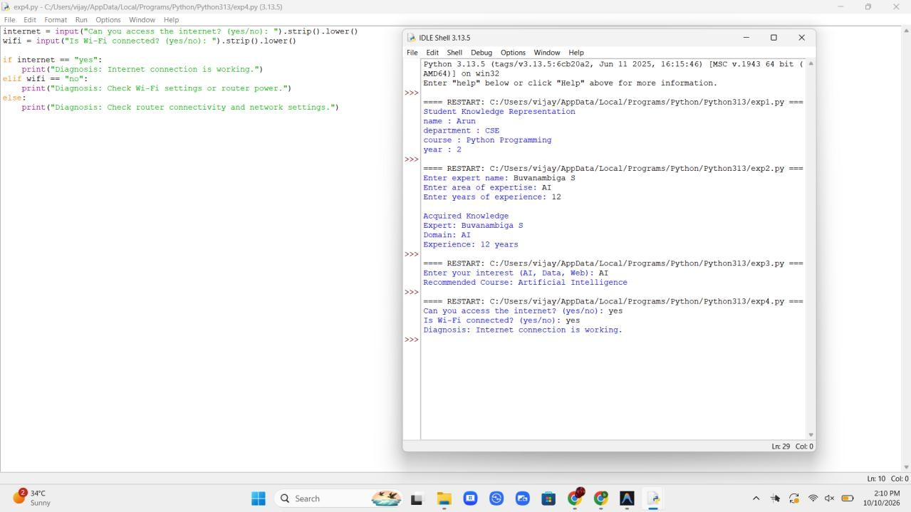

Result
A rule-based expert system was implemented that examined the symptoms entered by the user and displayed a suitable troubleshooting action. This is a teaching demonstration, not a professional diagnostic tool.

Experiment 5: Semantic Network Using NetworkX

Aim
To represent concepts and their labelled relationships as a semantic network and to infer inherited properties from it.

Software Required
Python 3.x (IDLE / any Python IDE) and NetworkX (pip install networkx)

Algorithm
- Start the program. Import the networkx library as nx.
- Create a directed graph. Use nx.DiGraph() so that every relationship has a direction from source concept to target concept.
- Add the is-a links. Use add_edge() with relation="is-a" to connect Sparrow and Penguin to Bird, and Bird to Animal.
- Add property links. Add the labelled edges Bird has Wings, Bird can Fly and Animal needs Food.
- Display the network. Traverse G.edges(data=True) and print each relationship as source -- relation --> target.
- Infer inherited properties. Starting from Sparrow, follow the is-a links upward. At each concept print the non-is-a relations, which Sparrow inherits from its parents.
- Stop the program. The loop ends when a concept has no further parent.

Pseudocode

START
CREATE directed graph G
ADD edge Sparrow --is-a--> Bird ADD edge Penguin --is-a--> Bird ADD edge Bird --is-a--> Animal ADD edge Bird --has--> Wings ADD edge Bird --can--> Fly
ADD edge Animal --needs--> Food
FOR EACH edge (source, target, relation) IN G DISPLAY source, relation, target

END FOR
node <- "Sparrow" REPEAT
FOR EACH non is-a edge OF node DISPLAY "Sparrow", relation, target

END FOR
node <- parent of node (is-a) UNTIL node has no parent
STOP

Program
import networkx as nx

G = nx.DiGraph()
G.add_edge("Sparrow", "Bird", relation="is-a") G.add_edge("Penguin", "Bird", relation="is-a") G.add_edge("Bird", "Animal", relation="is-a") G.add_edge("Bird", "Wings", relation="has") G.add_edge("Bird", "Fly", relation="can") G.add_edge("Animal", "Food", relation="needs")

print("Semantic Network Relationships:")
for source, target, data in G.edges(data=True): print(source, "--", data["relation"], "-->", target)

print("\nInheritance query for Sparrow:") node = "Sparrow"
while True:
parents = [t for _, t, d in G.out_edges(node, data=True) if d["relation"] == "is-a"] for _, t, d in G.out_edges(node, data=True):
if d["relation"] != "is-a":
print("Sparrow", d["relation"], t, "(inherited from", node + ")") if not parents:
break
node = parents[0]

Output Screenshot
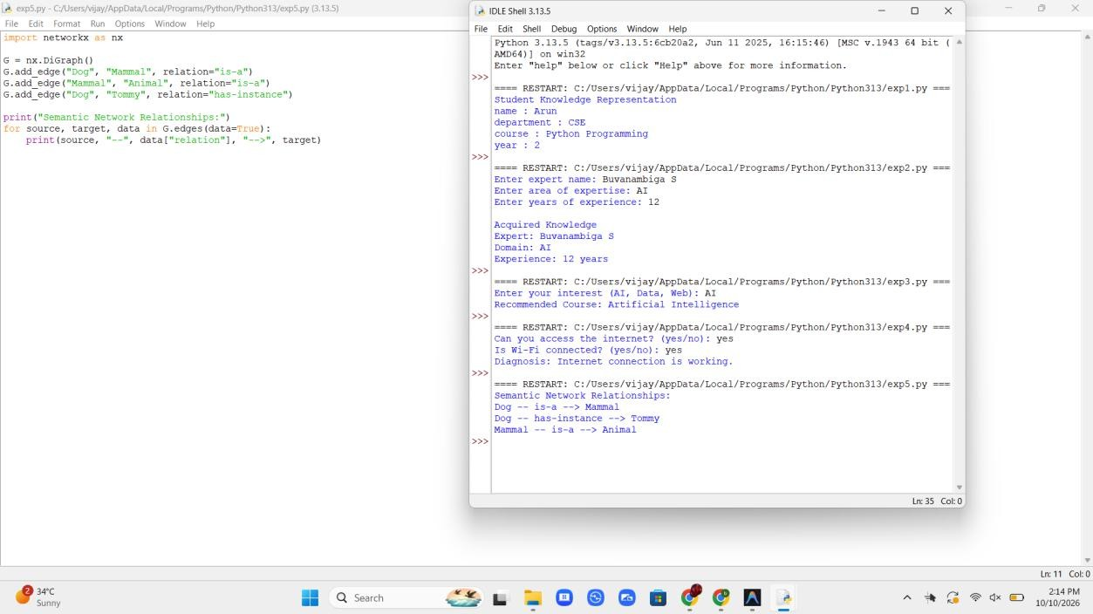

Result
The semantic network represented concepts and labelled relationships, and the inheritance query showed that Sparrow inherits the properties of Bird and Animal.

Experiment 6: Frame-Based Knowledge Representation

Aim
To represent objects as frames with slots and values, and to retrieve slot values through inheritance from parent frames.

Software Required
Python 3.x (IDLE / any Python IDE)

Algorithm
- Start the program. Plan a three-level frame hierarchy: Vehicle, Car and MyCar.
- Create the general frame. Create the dictionary vehicle with the slots wheels, engine and fuel, and set is_a to None.
- Create the specialised frame. Create the dictionary car with the slots doors and seats, and link it to vehicle using the is_a slot.
- Create the instance frame. Create my_car with the slots brand, color and fuel, and link it to car. The fuel slot overrides the default value of the parent.
- Define get_slot(). Search the given frame for the slot. If it is missing, move to the parent frame through is_a and repeat until the slot is found or no parent remains.
- Display the frame. For every slot, print the value and mention the frame it was inherited from. Print "not defined" if no frame holds the slot.
- Stop the program.

Pseudocode

START
CREATE frame Vehicle (wheels, engine, fuel) CREATE frame Car (doors, seats) WITH parent Vehicle
CREATE frame MyCar (brand, color, fuel) WITH parent Car FUNCTION get_slot(frame, slot)
WHILE frame EXISTS
IF slot IN frame THEN RETURN value, frame name

END IF
frame <- parent of frame END WHILE
RETURN none END FUNCTION
FOR EACH slot IN slot list
value, owner <- get_slot(MyCar, slot) DISPLAY slot, value, owner
END FOR STOP

Program
vehicle = {"name": "Vehicle", "is_a": None, "wheels": 4, "engine": True, "fuel": "Petrol"}
car = {"name": "Car", "is_a": vehicle, "doors": 4, "seats": 5}
my_car = {"name": "MyCar", "is_a": car, "brand": "Honda", "color": "Red", "fuel": "Diesel"}

def get_slot(frame, slot): while frame is not None:
if slot in frame:
return frame[slot], frame["name"] frame = frame["is_a"]
return None, None

print("Frame: MyCar")
for slot in ["brand", "color", "fuel", "doors", "seats", "wheels", "engine", "price"]: value, owner = get_slot(my_car, slot)
if owner is None:
print(slot, ": not defined") elif owner == "MyCar":
print(slot, ":", value) else:
print(slot, ":", value, "(inherited from", owner + ")")

Output Screenshot
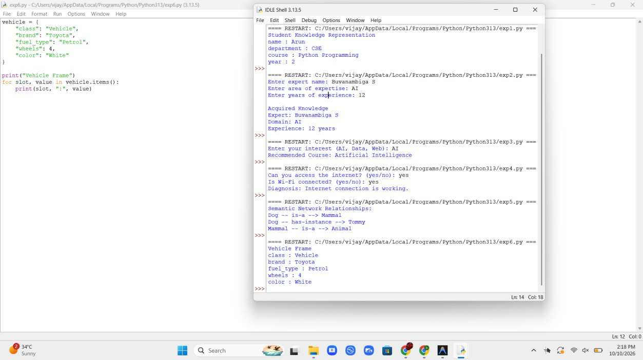

Result
Objects were represented as frames with slots, and slot values were retrieved from parent frames by inheritance. The overriding value in the instance frame took priority over the default.

Experiment 7: Production Rules and Forward Chaining

Aim
To implement IF-THEN production rules and to derive new facts from known facts using forward chaining.

Software Required
Python 3.x (IDLE / any Python IDE)

Algorithm
- Start the program. Decide the problem: finding the scholarship eligibility of a student.
- Initialise the facts. Store marks_above_80, attendance_above_75 and family_income_low in a set named facts.
- Define the rules. Store each rule as a name, a set of conditions and a conclusion, for example R1: marks and attendance give eligible_for_merit.
- Scan the rules. For every rule, check whether all its conditions are present in facts using issubset().
- Fire a rule. If the conditions are satisfied and the conclusion is new, add it to facts and print the rule name and the inferred fact.
- Repeat. Keep scanning the rules until a full pass adds no new fact.
- Display the final facts and stop. Print all facts in sorted order.

Pseudocode

START
facts <- {marks_above_80, attendance_above_75, family_income_low} rules <- R1, R2, R3, R4 (conditions -> conclusion)

REPEAT
changed <- FALSE
FOR EACH rule IN rules
IF conditions OF rule ARE IN facts
AND conclusion IS NOT IN facts THEN ADD conclusion TO facts
DISPLAY rule name, conclusion changed <- TRUE

END IF END FOR
UNTIL changed = FALSE DISPLAY facts
STOP

Program
facts = {"marks_above_80", "attendance_above_75", "family_income_low"}

rules = [
("R1", {"marks_above_80", "attendance_above_75"}, "eligible_for_merit"), ("R2", {"family_income_low"}, "eligible_for_need_based"),
("R3", {"eligible_for_merit", "eligible_for_need_based"}, "full_scholarship"), ("R4", {"full_scholarship"}, "send_approval_letter"),
]

print("Initial Facts:", sorted(facts)) print()

step = 1 changed = True while changed:
changed = False
for name, conditions, conclusion in rules:
if conditions.issubset(facts) and conclusion not in facts: facts.add(conclusion)
print("Step", step, ": Rule", name, "fired ->", conclusion) step += 1
changed = True

print("\nFinal Facts:") for fact in sorted(facts):
print("-", fact)

Output Screenshot
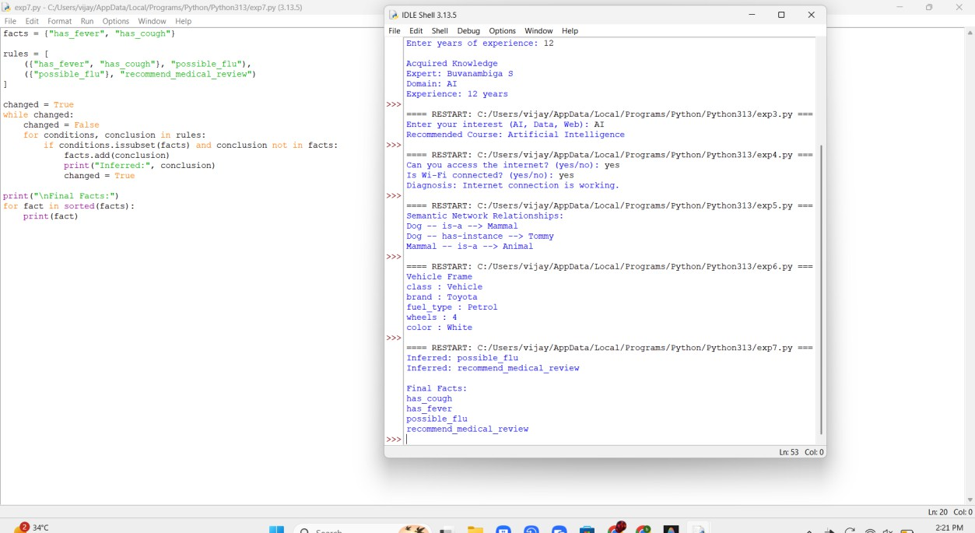

Result
Forward chaining started with three known facts and derived four new facts by repeatedly applying the production rules. The scholarship rules are illustrative only.

Experiment 8: Ontology Development Using Protégé

Aim
To create a simple library ontology with classes, an object property and individuals, and to use a reasoner to infer new knowledge.

Software Required
Protégé Desktop 5.x with the HermiT reasoner

Algorithm
- Start Protégé. Create a new ontology and set its IRI to http://example.org/LibraryOntology.
- Create the classes. On the Classes tab add Person and Book under Thing.
- Create the subclasses. Add Member and Librarian as subclasses of Person.
- Create the object property. On the Object Properties tab add borrows, then set its Domain to Member and its Range to Book.
- Create the individuals. On the Individuals tab add Meera (type Member), DataScienceBook (type Book), PythonBook (type Book) and Ravi (no type given).
- Assert the facts. Add the object property assertions Meera borrows DataScienceBook and Ravi borrows PythonBook.
- Run the reasoner. Select Reasoner > HermiT > Start reasoner.
- Inspect the inferred knowledge. Select Ravi and read the inferred types, shown with a yellow background. Save the ontology as an .owl file.

Pseudocode

START
CREATE ontology LibraryOntology CREATE classes Person, Book CREATE classes Member, Librarian Member SUBCLASS_OF Person Librarian SUBCLASS_OF Person CREATE object property borrows
DOMAIN <- Member RANGE <- Book
CREATE individual Meera OF TYPE Member
CREATE individuals DataScienceBook, PythonBook OF TYPE Book CREATE individual Ravi (no type)
ASSERT Meera borrows DataScienceBook ASSERT Ravi borrows PythonBook
RUN reasoner
DISPLAY inferred types OF Ravi STOP

Implementation Steps
Classes:
Thing
Person
Member Librarian
Book

Object property:
borrows (Domain: Member, Range: Book)

Individuals:
Meera : Member DataScienceBook : Book PythonBook : Book
Ravi : (no type asserted)

Property assertions:
Meera borrows DataScienceBook Ravi borrows PythonBook

Expected inference after running HermiT:
Ravi is a Member (from the domain of borrows) Ravi is a Person (Member is a subclass of Person) Meera is a Person (Member is a subclass of Person)

Output Screenshot
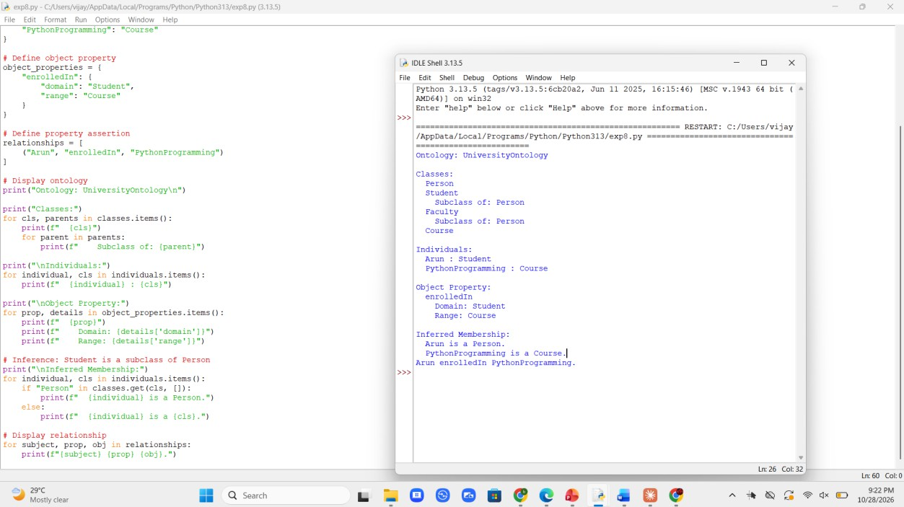

Result
A library ontology was created in Protégé, and the HermiT reasoner inferred that Ravi is a Member and a Person from the domain of the borrows property and the subclass relationships.

Experiment 9: Knowledge Graph Construction Using Python

Aim
To construct a knowledge graph of entities and relationships using a directed graph, and to query it.

Software Required
Python 3.x (IDLE / any Python IDE) and NetworkX (pip install networkx)

Algorithm
- Start the program. Import the networkx library as nx.
- Create a directed graph. Use nx.DiGraph() and store it in the variable kg.
- Add the director relationships. Add edges with relation="directed" from Christopher Nolan to Inception and Interstellar.
- Add the actor relationships. Add edges with relation="acted_in" from each actor to the movie he acted in.
- Add the genre relationships. Add edges with relation="has_genre" from each movie to Sci-Fi.
- Display the triples. Traverse kg.edges(data=True) and print each edge as (subject, relation, object).
- Display graph statistics. Use number_of_nodes() and number_of_edges() to print the number of entities and relationships.
- Query the graph. Read the out-edges of Christopher Nolan and print the movies whose relation is "directed". Then stop.

Pseudocode

START
CREATE directed graph kg
ADD (Christopher Nolan, directed, Inception) ADD (Christopher Nolan, directed, Interstellar) ADD (Leonardo DiCaprio, acted_in, Inception)
ADD (Matthew McConaughey, acted_in, Interstellar) ADD (Inception, has_genre, Sci-Fi)
ADD (Interstellar, has_genre, Sci-Fi) FOR EACH edge IN kg
DISPLAY (subject, relation, object) END FOR
DISPLAY number of nodes DISPLAY number of edges
FOR EACH edge FROM "Christopher Nolan" IF relation = "directed" THEN
DISPLAY movie END IF
END FOR STOP

Program
import networkx as nx

kg = nx.DiGraph()
kg.add_edge("Christopher Nolan", "Inception", relation="directed") kg.add_edge("Christopher Nolan", "Interstellar", relation="directed") kg.add_edge("Leonardo DiCaprio", "Inception", relation="acted_in") kg.add_edge("Matthew McConaughey", "Interstellar", relation="acted_in") kg.add_edge("Inception", "Sci-Fi", relation="has_genre") kg.add_edge("Interstellar", "Sci-Fi", relation="has_genre")

print("Knowledge Graph Triples:")
for subject, obj, data in kg.edges(data=True): print("(", subject, ",", data["relation"], ",", obj, ")")

print("\nTotal entities:", kg.number_of_nodes()) print("Total relationships:", kg.number_of_edges())

print("\nQuery: Movies directed by Christopher Nolan")
for _, movie, data in kg.out_edges("Christopher Nolan", data=True): if data["relation"] == "directed":
print("-", movie)

Output Screenshot
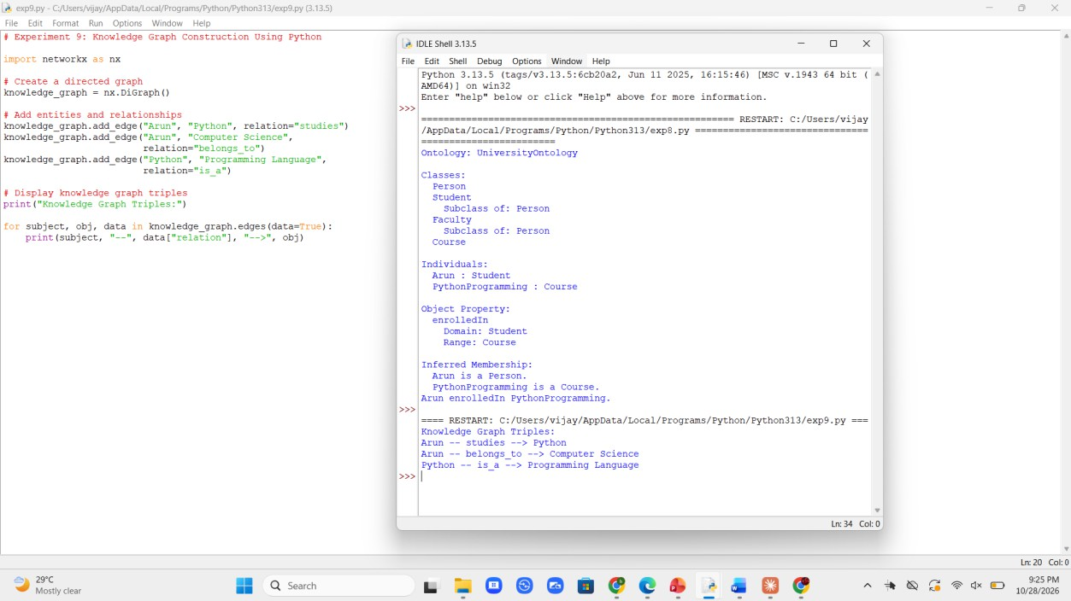

Result
A knowledge graph was constructed with entities as nodes and relationships as labelled edges, and a simple query retrieved the movies directed by a given person.

Experiment 10: Knowledge Management System

Aim
To build a menu-driven knowledge management system that can add, search and display knowledge items.

Software Required
Python 3.x (IDLE / any Python IDE)

Algorithm
- Start the program. Create an empty dictionary named knowledge_base to hold topics and their details.
- Display the menu. Inside a while loop show the options: add, search, display all and exit.
- Add knowledge. If the choice is 1, read a topic and its details and store them in the dictionary.
- Search knowledge. If the choice is 2, read a keyword and print every item whose topic or details contain it. Print a message if nothing matches.
- Display all knowledge. If the choice is 3, print every topic with its details, or report that the knowledge base is empty.
- Handle invalid input. For any other value except 4, print an error message and show the menu again.
- Exit. If the choice is 4, print a message and leave the loop to stop the program.

Pseudocode

START
CREATE empty dictionary knowledge_base REPEAT
DISPLAY menu READ choice
IF choice = 1 THEN READ topic, details
knowledge_base[topic] <- details ELSE IF choice = 2 THEN
READ keyword
FOR EACH (topic, details) IN knowledge_base IF keyword IN topic OR details THEN
DISPLAY topic, details END IF

END FOR
ELSE IF choice = 3 THEN DISPLAY all items
ELSE IF choice = 4 THEN EXIT loop

ELSE
DISPLAY "Invalid choice" END IF
UNTIL choice = 4 STOP

Program
knowledge_base = {}

while True:
print("\n--- Knowledge Management System ---") print("1. Add knowledge")
print("2. Search knowledge") print("3. Display all knowledge") print("4. Exit")
choice = input("Enter your choice: ").strip()

if choice == "1":
topic = input("Enter topic: ").strip().lower() details = input("Enter details: ").strip() knowledge_base[topic] = details print("Knowledge stored successfully.")
elif choice == "2":
keyword = input("Enter keyword to search: ").strip().lower() found = False
for topic, details in knowledge_base.items():
if keyword in topic or keyword in details.lower(): print(topic.title(), ":", details)
found = True if not found:
print("No matching knowledge found.") elif choice == "3":
if not knowledge_base: print("Knowledge base is empty.")
for topic, details in knowledge_base.items(): print(topic.title(), ":", details)
elif choice == "4": print("Exiting the system.") break
else:
print("Invalid choice. Try again.")

Output Screenshot
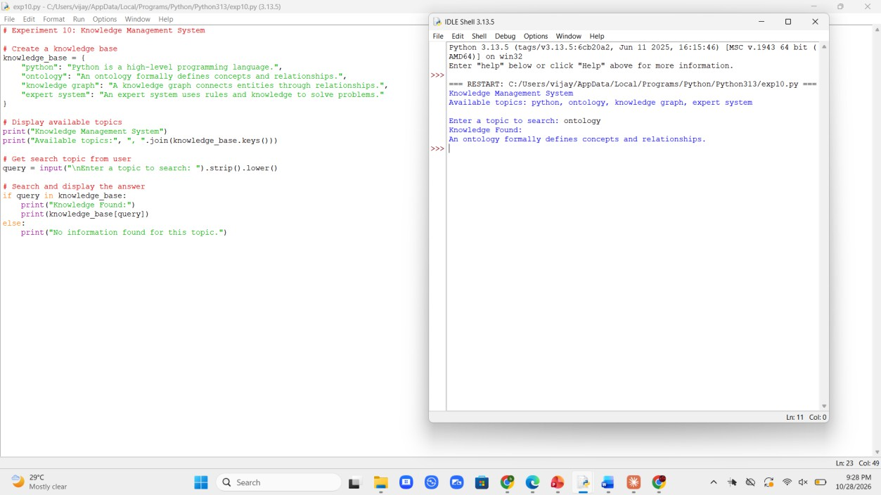

Result
A menu-driven knowledge management system was developed that captured, stored, searched and displayed knowledge items using a dictionary.

Experiment 11: RDF Knowledge Representation Using RDFLib

Aim
To represent facts as RDF triples, query them, and display the graph in Turtle format.

Software Required
Python 3.x (IDLE / any Python IDE) and RDFLib (pip install rdflib)

Algorithm
- Start the program. Import Graph, Namespace, Literal and RDF from the rdflib library.
- Create the graph and namespace. Create an empty Graph and the namespace EX = http://example.org/, then bind the prefix ex.
- Add type triples. Use g.add() with RDF.type to state that Meera is a Student and Karthik is a Teacher.
- Add property triples. Add the triples for name, studies, teaches and credits. Use Literal for plain values such as the name and credits.
- Display the triples. Iterate over the graph in sorted order and print each subject, predicate and object using the ex prefix.
- Count the triples. Print len(g) as the total number of triples.
- Query the graph. Use g.subjects(EX.studies, EX.DataScience) to find who studies DataScience.
- Serialise the graph. Use g.serialize(format="turtle") to print the graph in Turtle format, then stop.

Pseudocode

START
CREATE graph g
DEFINE namespace EX <- "http://example.org/" ADD (Meera, type, Student)
ADD (Meera, name, "Meera") ADD (Meera, studies, DataScience) ADD (Karthik, type, Teacher)
ADD (Karthik, teaches, DataScience) ADD (DataScience, credits, 4)
FOR EACH (s, p, o) IN g DISPLAY s, p, o

END FOR
DISPLAY number of triples
FIND subjects WHERE predicate = studies AND object = DataScience DISPLAY subjects
SERIALISE g AS Turtle DISPLAY result
STOP

Program
from rdflib import Graph, Namespace, Literal, RDF

g = Graph()
EX = Namespace("http://example.org/") g.bind("ex", EX)

g.add((EX.Meera, RDF.type, EX.Student)) g.add((EX.Meera, EX.name, Literal("Meera"))) g.add((EX.Meera, EX.studies, EX.DataScience)) g.add((EX.Karthik, RDF.type, EX.Teacher)) g.add((EX.Karthik, EX.teaches, EX.DataScience)) g.add((EX.DataScience, EX.credits, Literal(4)))

print("RDF Triples:") for s, p, o in sorted(g):
print(s.n3(g.namespace_manager), p.n3(g.namespace_manager), o.n3(g.namespace_manager))
print("\nTotal triples:", len(g)) print("\nQuery: Who studies DataScience?")
for s in g.subjects(EX.studies, EX.DataScience): print(s)

print("\nTurtle format:") print(g.serialize(format="turtle"))

Output Screenshot

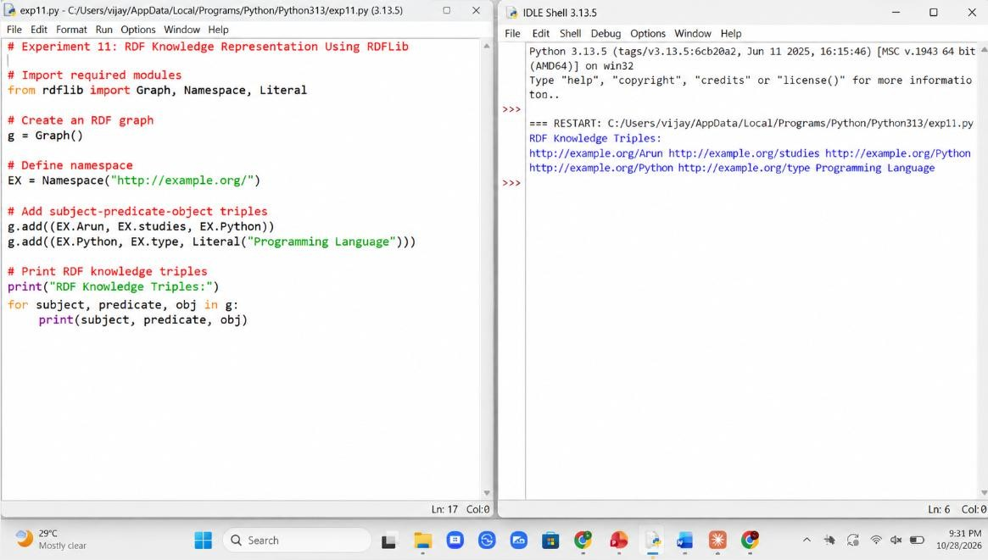

Result
Knowledge was represented as RDF subject-predicate-object triples, queried using RDFLib, and displayed in Turtle format. The order of the triples in the graph may vary.

Experiment 12: Knowledge Graph Traversal Using NetworkX

Aim
To traverse a knowledge graph using breadth-first search (BFS) and to find the shortest path between two entities.

Software Required
Python 3.x (IDLE / any Python IDE) and NetworkX (pip install networkx)

Algorithm
- Start the program. Import networkx and deque from the collections module.
- Build the graph. Create a graph with add_edges_from() linking concepts such as Meera, Data Science, Machine Learning and Deep Learning.
- Read the entities. Accept the starting entity and the target entity from the user and check that both exist in the graph.
- Initialise BFS. Put the path [start] in a queue and mark start as visited.
- Process the queue. Remove the first path, take its last node and record the node in the visiting order.
- Check the target. If the node is the target, return the path.
- Expand the node. Otherwise add every unvisited neighbour to the visited set and push the extended path into the queue.
- Display the result and stop. Print the BFS visiting order, the shortest path and its length, or a message if no path exists.

Pseudocode

START
CREATE graph G, READ start, target IF start OR target NOT IN G THEN
DISPLAY "Entity not found" STOP

END IF
queue <- [[start]], visited <- {start}
WHILE queue IS NOT EMPTY
path <- REMOVE first path FROM queue node <- last node OF path
ADD node TO order IF node = target THEN
DISPLAY order, path, length STOP

END IF
FOR EACH neighbour OF node
IF neighbour NOT IN visited THEN ADD neighbour TO visited
ADD (path + neighbour) TO queue END IF

END FOR END WHILE

DISPLAY "No path found" STOP

Program
import networkx as nx
from collections import deque

G = nx.Graph() G.add_edges_from([
("Meera", "Data Science"),
("Data Science", "Machine Learning"), ("Machine Learning", "Neural Networks"), ("Data Science", "Statistics"),
("Meera", "Library"),
("Neural Networks", "Deep Learning"),
])

def bfs_path(graph, start, target): queue = deque([[start]]) visited = {start}
order = [] while queue:
path = queue.popleft() node = path[-1] order.append(node)
if node == target: return path, order
for neighbour in graph.neighbors(node): if neighbour not in visited:
visited.add(neighbour) queue.append(path + [neighbour])
return None, order

start = input("Enter starting entity: ").strip() target = input("Enter target entity: ").strip()

if start not in G or target not in G:
print("Entity not found in the knowledge graph.") else:
path, order = bfs_path(G, start, target)
print("Nodes visited (BFS order):", " , ".join(order)) if path:
print("Shortest Path:", " -> ".join(path)) print("Path length:", len(path) - 1, "edges")
else:
print("No path found.")

Output Screenshot
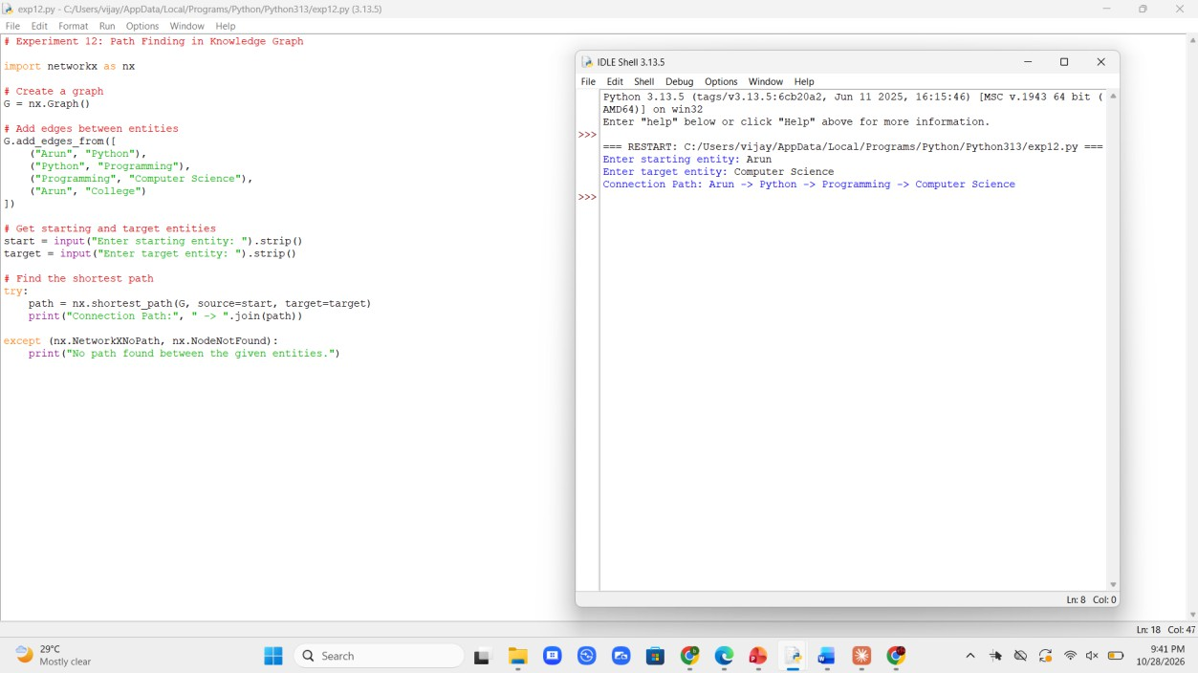

Result
Breadth-first search traversed the knowledge graph level by level and found the shortest connection between the two entities.

